Prediction of recurrence in non-small cell lung cancer patients with gene expression data using machine learning techniques
Sudipto Bhattacharjee¹, Banani Saha¹, Sudipto Saha²
ttsudipto@gmail.com; bsaha_29@yahoo.com; ssaha4@jcbose.ac.in
¹Department of Computer Science and Engineering, University of Calcutta, JD-2, Sector-III, Salt Lake, Kolkata-700098, India
² Division of Bioinformatics, Bose Institute, EN 80, Sector V, Bidhan Nagar, Kolkata – 700091, India
* Corresponding author:
Dr. Sudipto Saha
Division of Bioinformatics, Bose Institute
Unified Academic Campus, Bose Institute
EN 80, Sector V, Bidhan Nagar, Kolkata – 700091, WB, India
Email: ssaha4@jcbose.ac.in, ssaha4@gmail.com

Supplementary data 1
Table ST1 - Optimal hyperparameters given by the grid-search algorithm for models trained on original and SMOTE datasets with top features ranked by each feature ranking algorithm.
Dataset | Model | FS algorithm | Optimal feature size | Optimal hyperparameters
Original | SVM | MCFS | 140 | kernel=RBF, C=1, gamma=0.001
Original | SVM | Boruta | 20 | kernel=RBF, C=5, gamma=0.1
Original | SVM | MCFS + Boruta | 60 | kernel=RBF, C=5, gamma=0.0001
Original | RF | MCFS | 20 | number of trees = 200, max features = 0.25
Original | RF | Boruta | 60 | number of trees = 200, max features = 0.25
Original | RF | MCFS + Boruta | 60 | number of trees = 400, max features = None
Original | MLP | MCFS | 140 | hidden layer size= (175,87), learning rate = 0.001
Original | MLP | Boruta | 140 | hidden layer size= (200,200), learning rate = 0.0001
Original | MLP | MCFS + Boruta | 120 | hidden layer size= (50,25), learning rate = 0.001
SMOTE | SVM | MCFS | 60 | kernel=poly, C=1, degree=3, gamma=0.1, coefficient=1
SMOTE | SVM | Boruta | 140 | kernel=poly, C=5, degree=2, gamma=0.01, coefficient=1
SMOTE | SVM | MCFS + Boruta | 60 | kernel=poly, C=1, degree=2, gamma=0.1, coefficient=1
SMOTE | RF | MCFS | 100 | number of trees = 400, max features = 0.25
SMOTE | RF | Boruta | 100 | number of trees = 400, max features = 0.5
SMOTE | RF | MCFS + Boruta | 100 | number of trees = 400, max features = 0.25
SMOTE | MLP | MCFS | 120 | hidden layer size= (300,60), learning rate = 0.0001
SMOTE | MLP | Boruta | 120 | hidden layer size= (200,100), learning rate = 0.0001
SMOTE | MLP | MCFS + Boruta | 140 | hidden layer size= (250,250), learning rate = 0.0001
Abbreviations: MCFS Monte-Carlo Feature Selection, MLP Multi Layer Perceptron, RBF Radial Basis Function, RF Random Forest, SMOTE Synthetic Minority Over-sampling Technique, SVM Support Vector Machine.

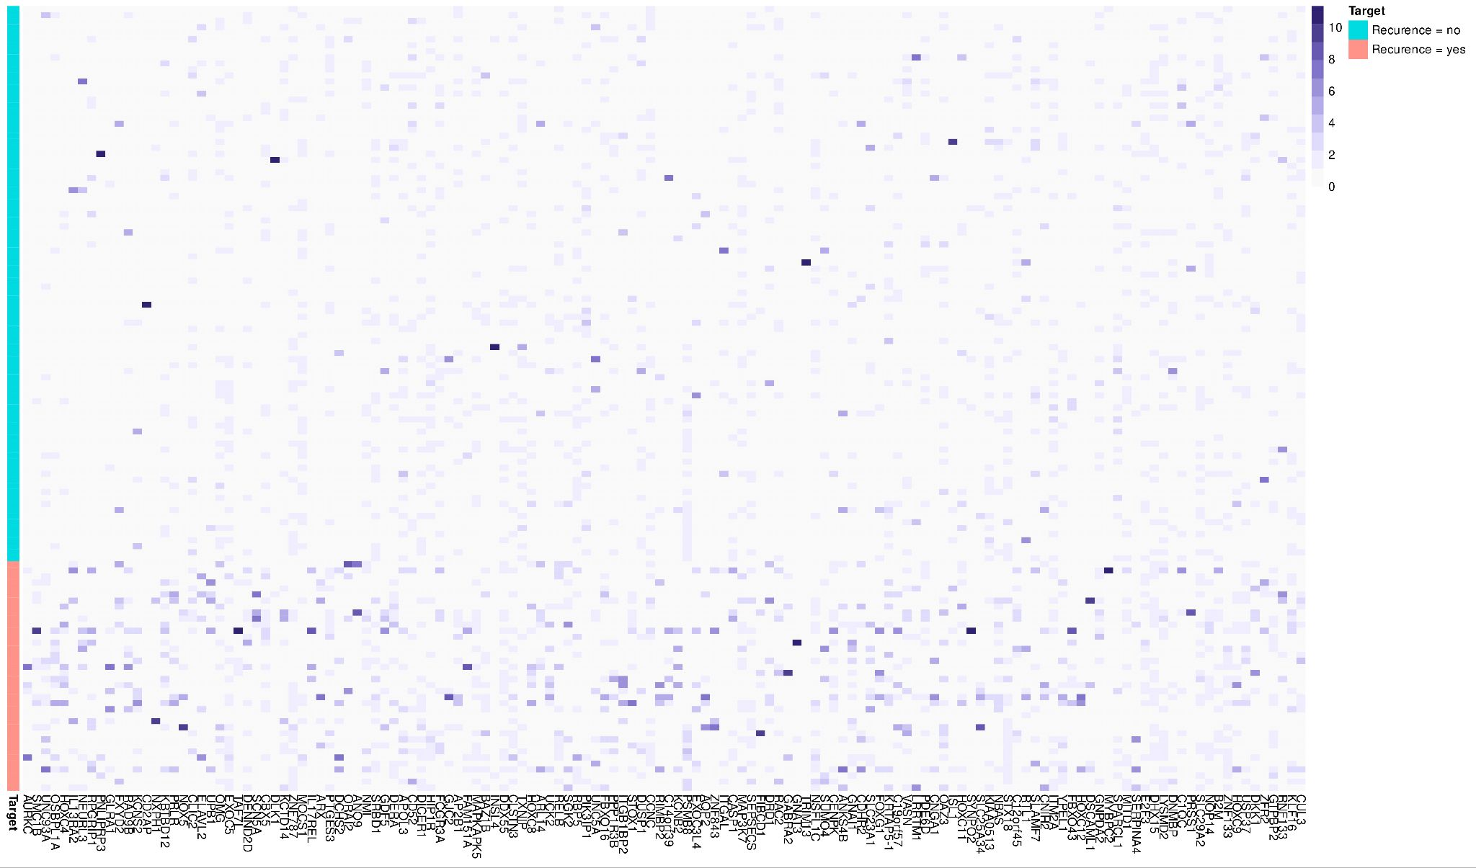
Fig. SF1 - Heatmap showing the expression values of top 140 genes ranked by MCFS.

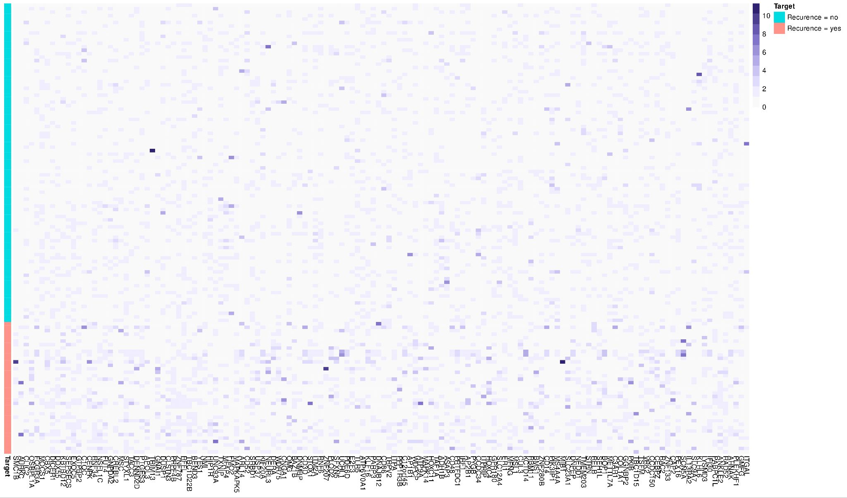
Fig. SF2 - Heatmap showing the expression values of top 140 genes ranked by Boruta.

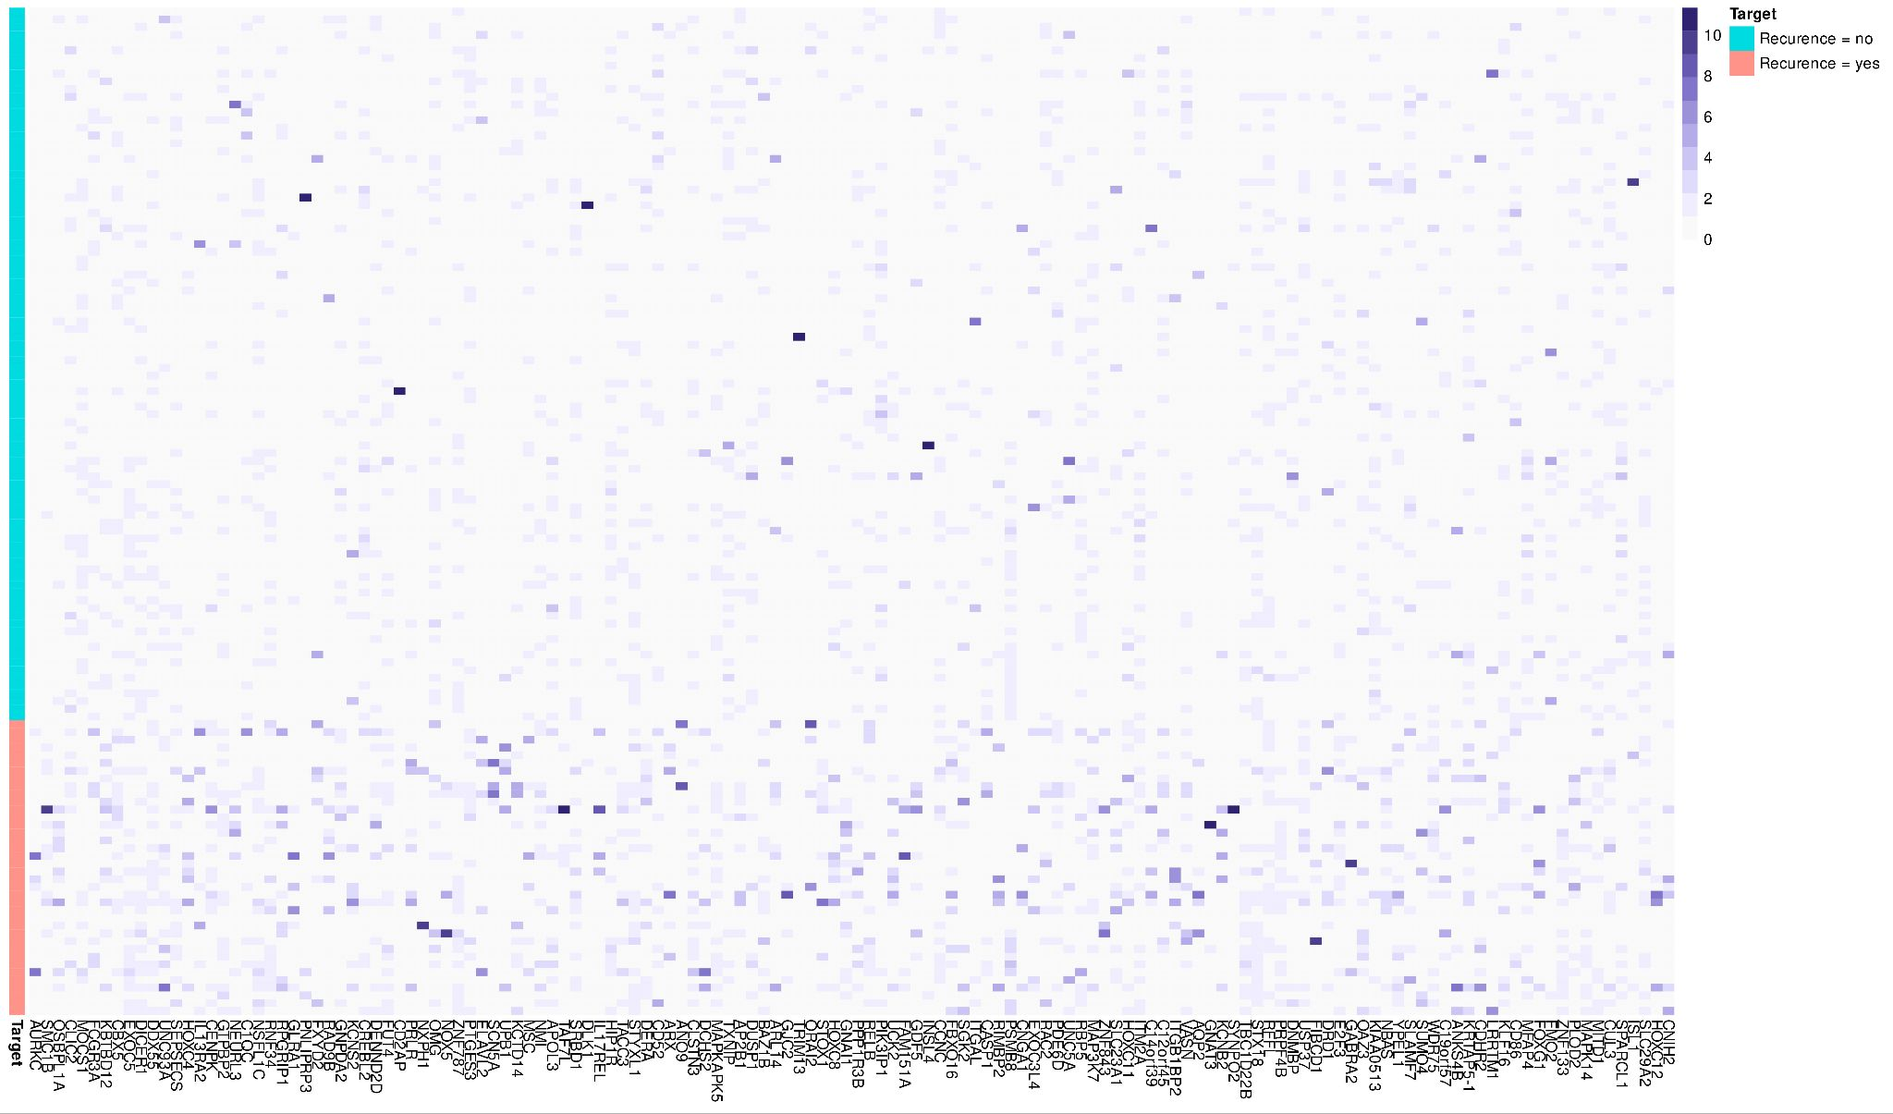
Fig. SF3 - Heatmap showing the expression values of top 140 genes ranked by MCFS+Boruta.

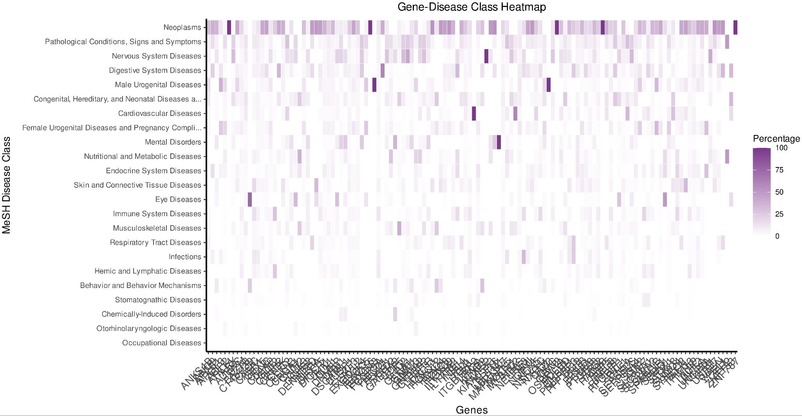
Fig. SF4 - Heatmap indicating the associations between the MeSH disease classes and the top 140 genes ranked by MCFS.

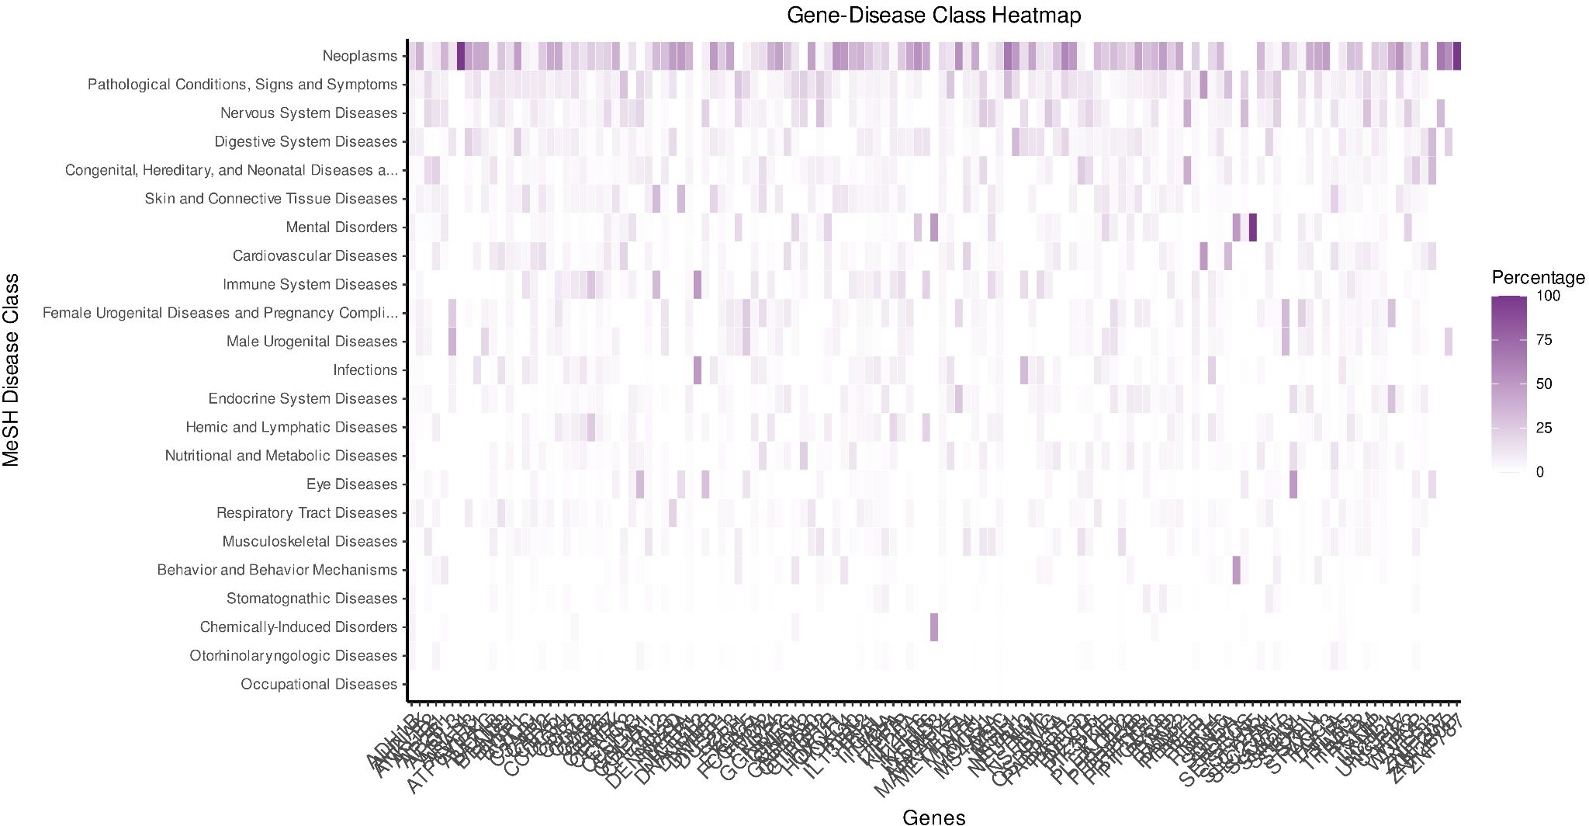
Fig. SF5 - Heatmap indicating the associations between the MeSH disease classes and the top 140 genes ranked by Boruta.

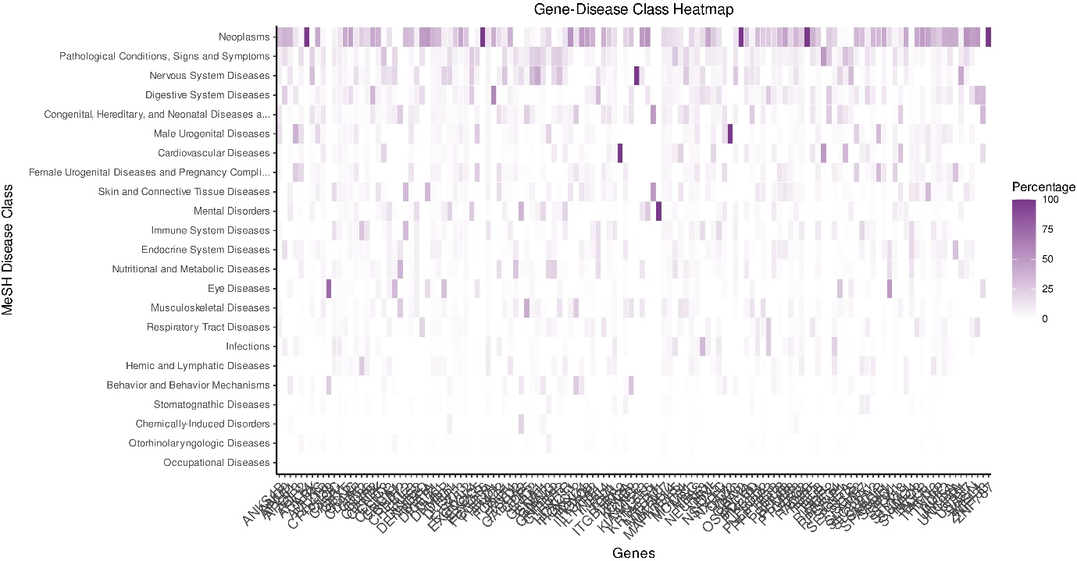
Fig. SF6 - Heatmap indicating the associations between the MeSH disease classes and the top 140 genes ranked by MCFS+Boruta.

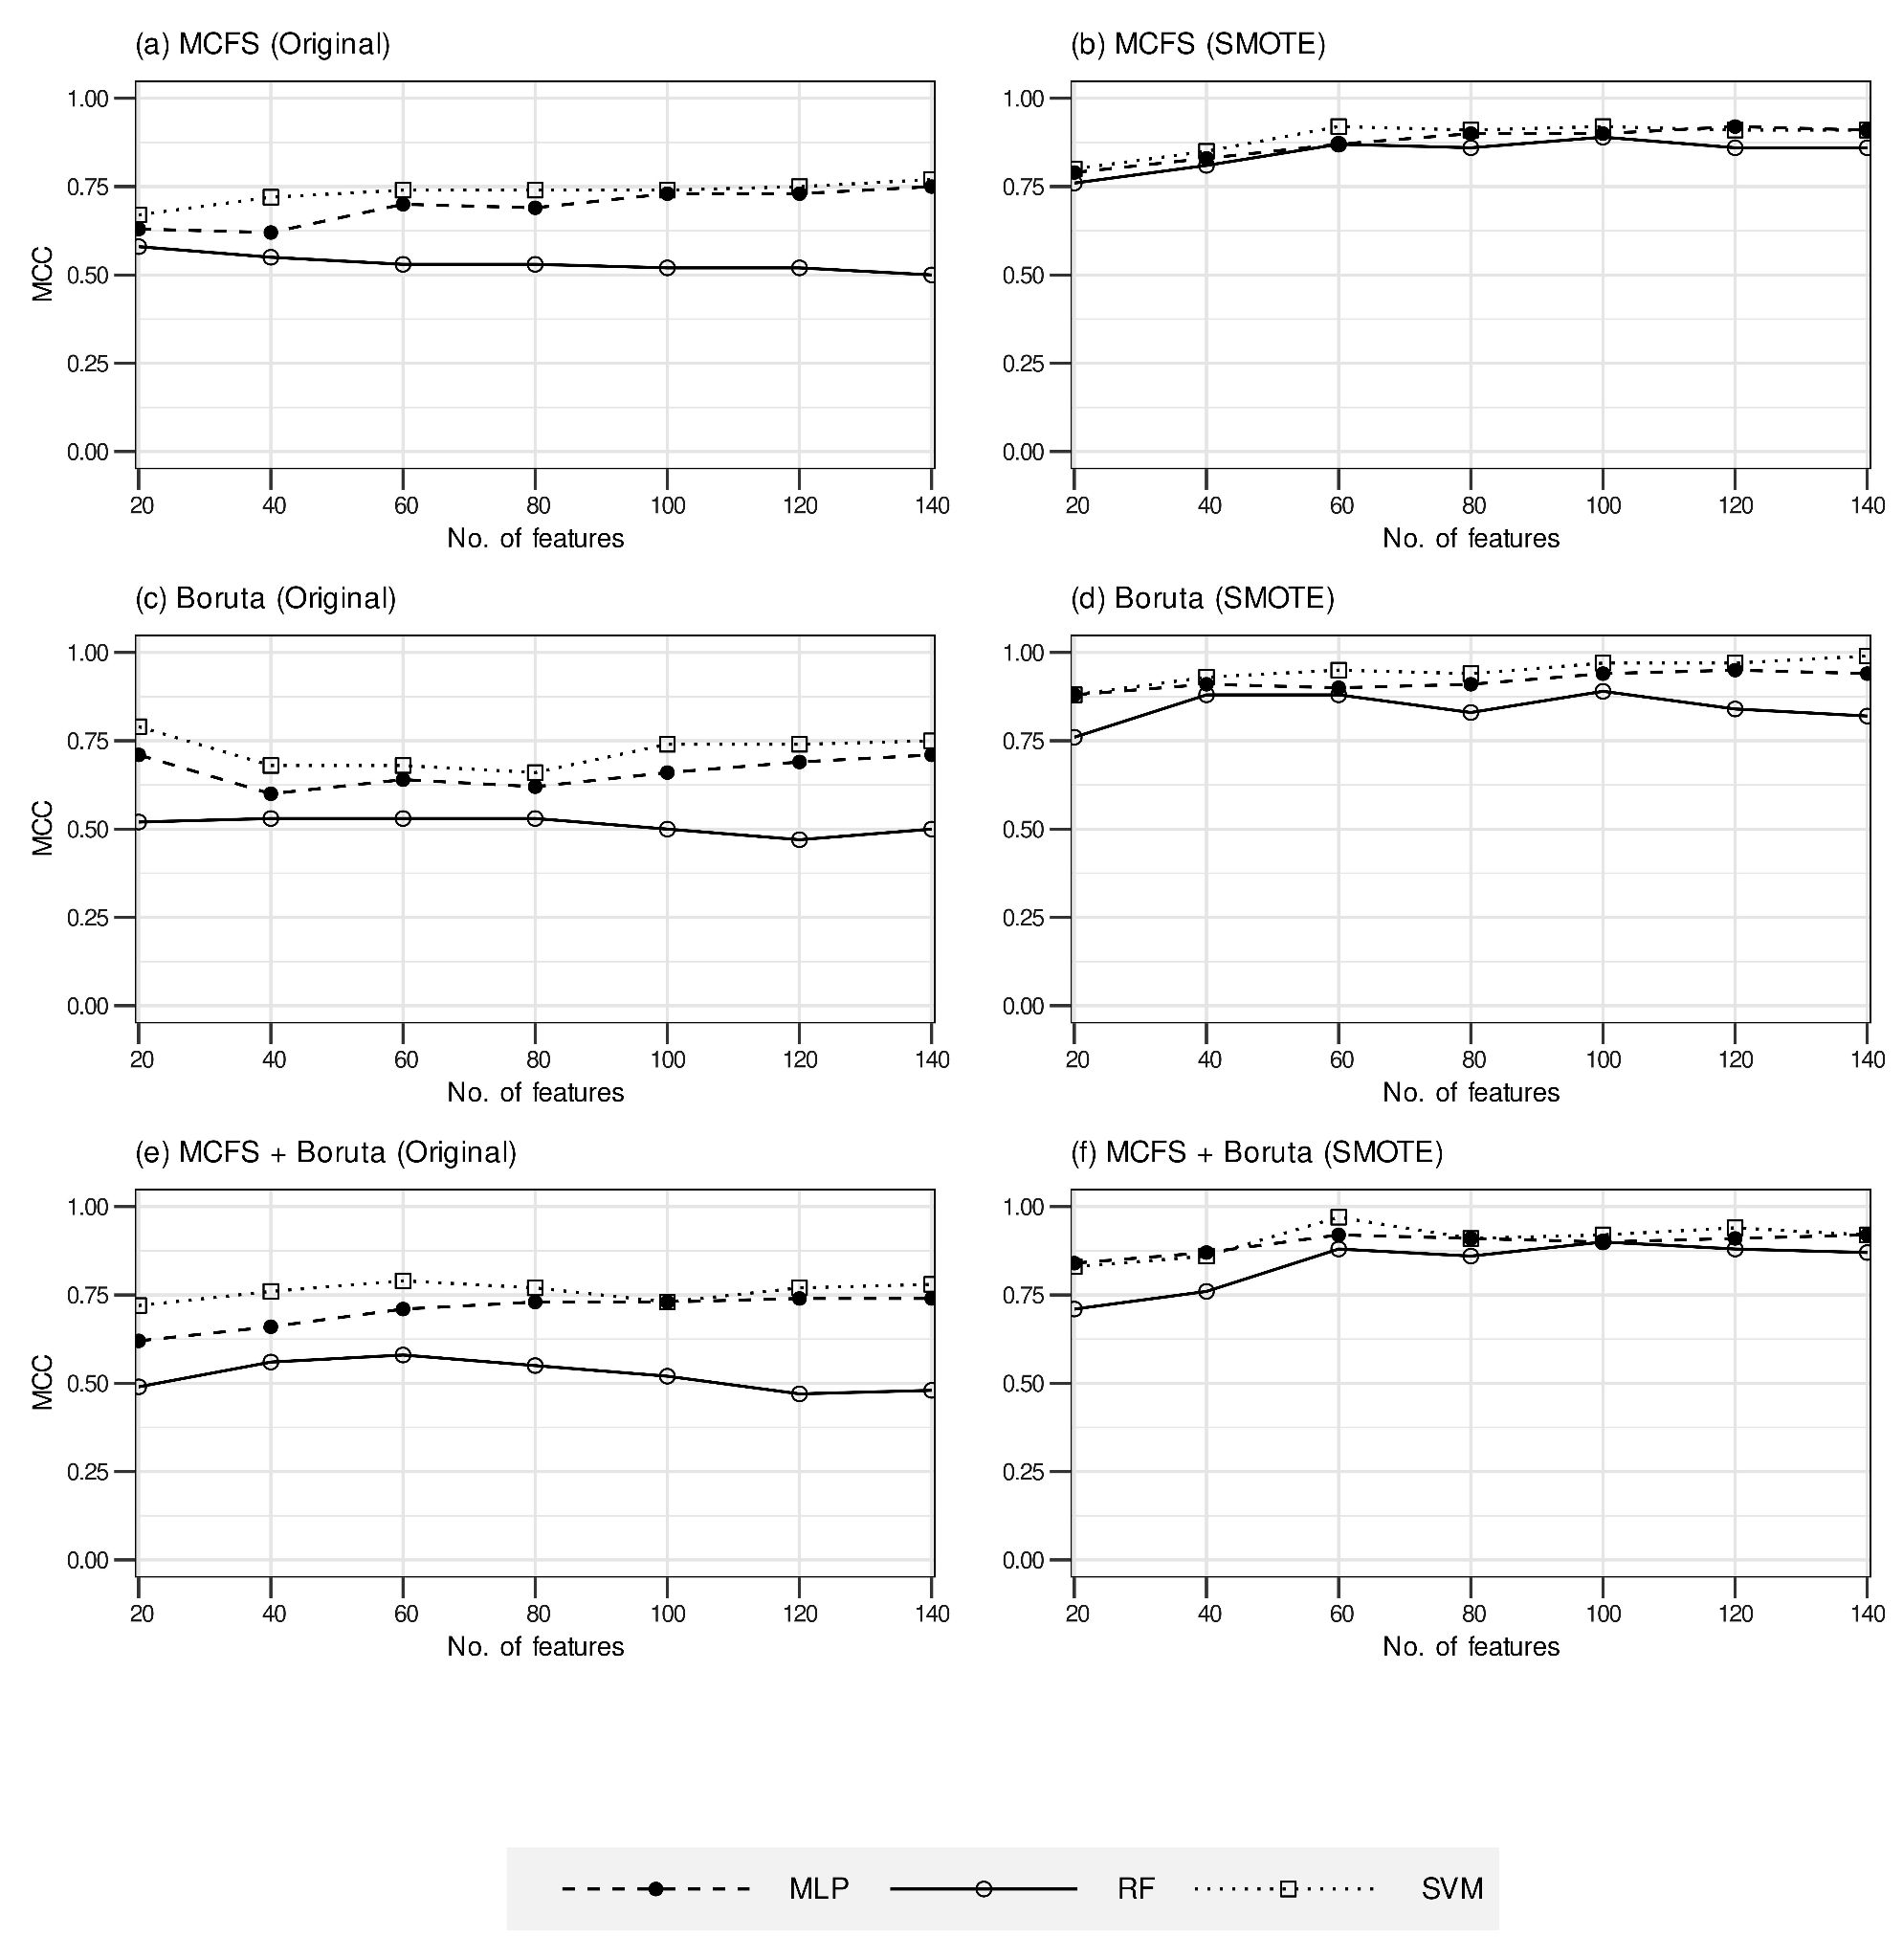
Fig. SF7 - Performance variation of the ML models in terms of MCC values with respect to the different feature sizes. (a) Models trained on original dataset with features from MCFS ranking, (b) Models trained on SMOTE dataset with features from MCFS ranking, (c) Models trained on original dataset with features from Boruta ranking, (d) Models trained on SMOTE dataset with features from Boruta ranking, (e) Models trained on original dataset with features from MCFS+Boruta ranking, and (f) Models trained on SMOTE dataset with features from MCFS+Boruta ranking.
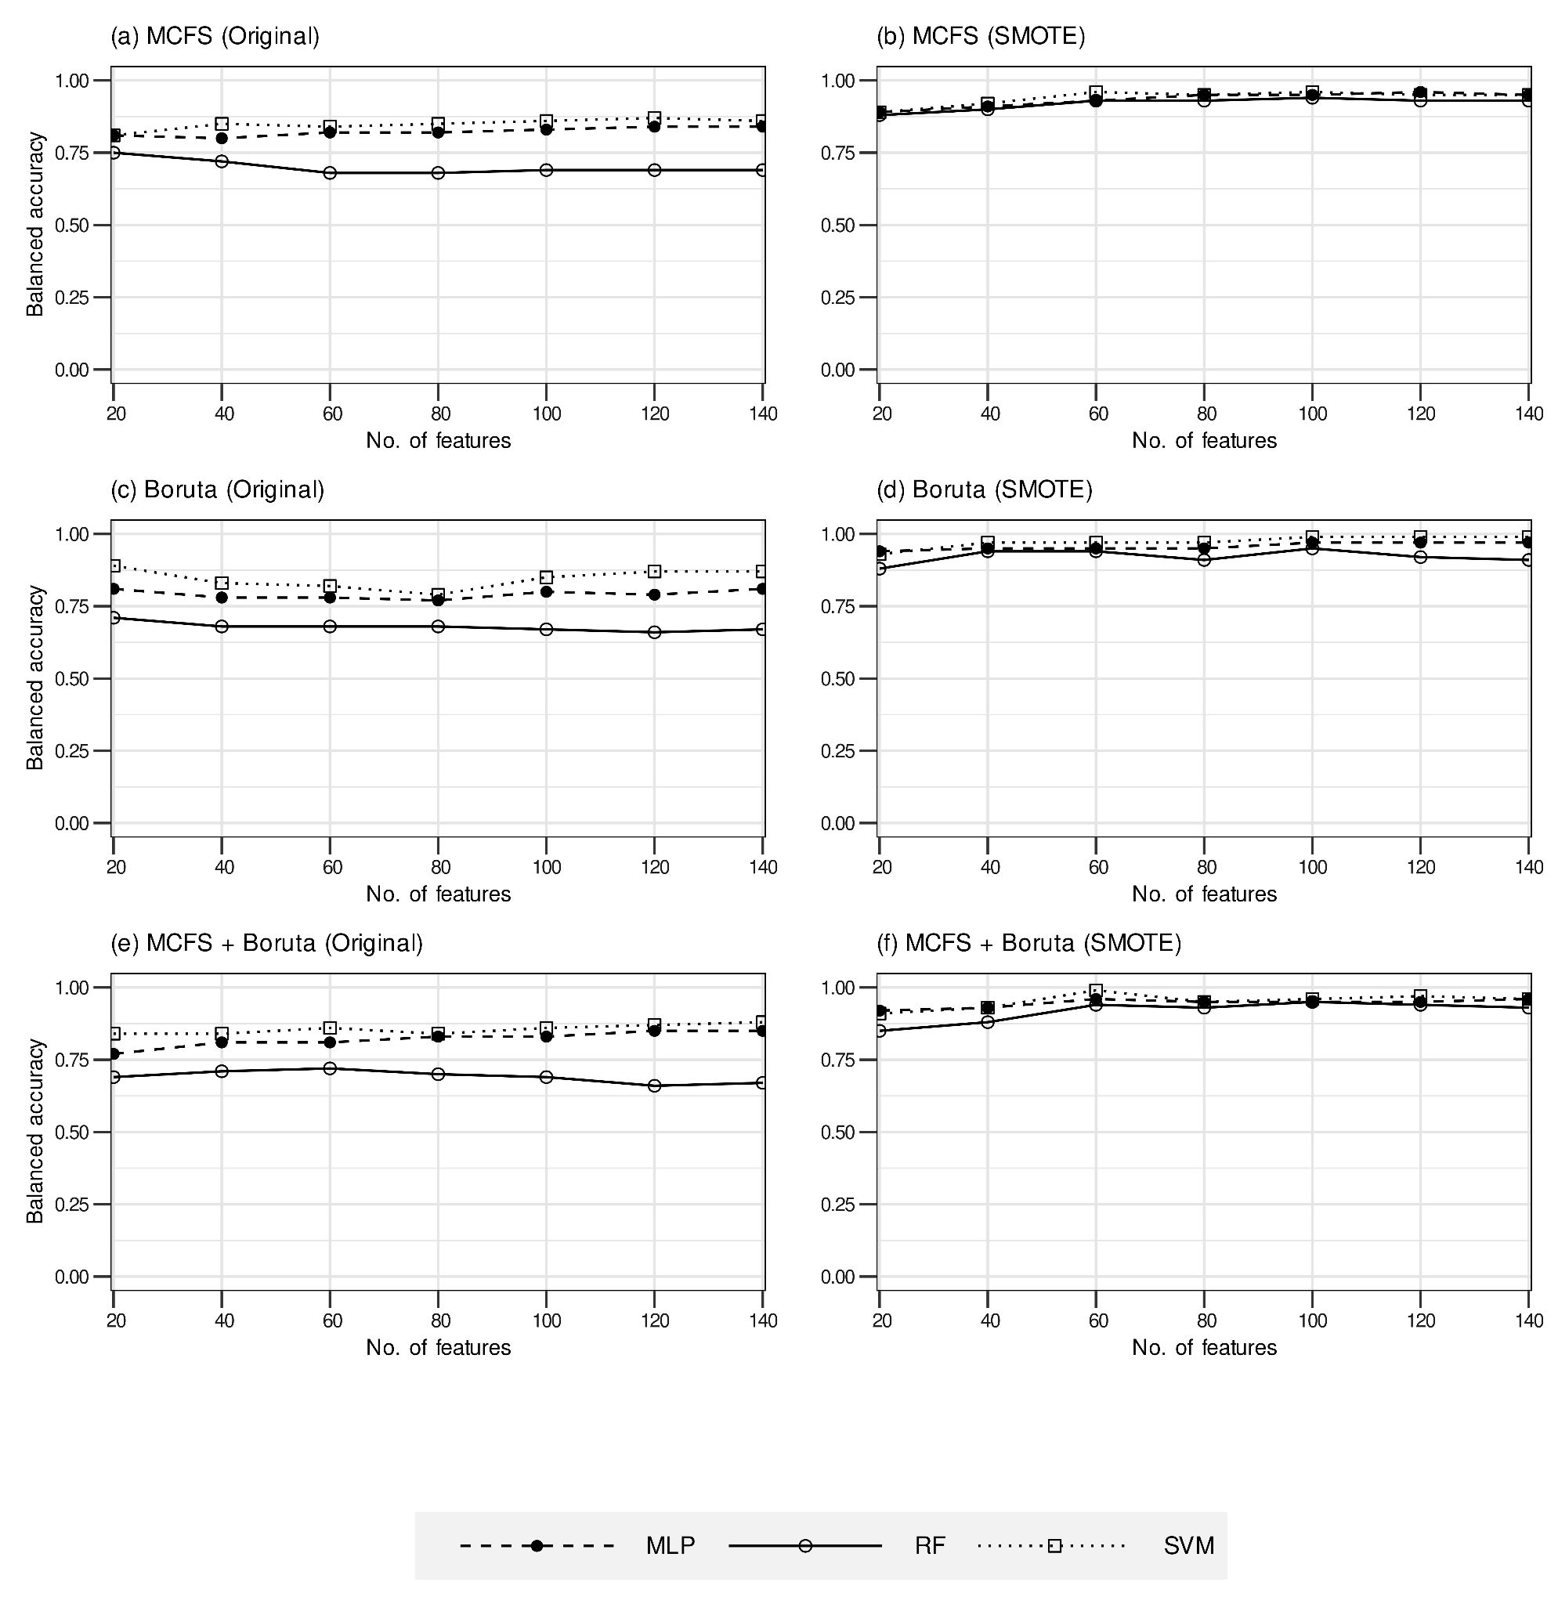
Fig. SF8 - Performance variation of the ML models in terms of balanced accuracy values with respect to the different feature sizes. (a) Models trained on original dataset with features from MCFS ranking, (b) Models trained on SMOTE dataset with features from MCFS ranking, (c) Models trained on original dataset with features from Boruta ranking, (d) Models trained on SMOTE dataset with features from Boruta ranking, (e) Models trained on original dataset with features from MCFS+Boruta ranking, and (f) Models trained on SMOTE dataset with features from MCFS+Boruta ranking.

